SUPRAMAR WISE 2000

( SUPRAMAR WING IN SURFACE EFFECT 2000 )

HARBOUR  MANOEUVRING  - REAR FOILS DOWN  - FRONT FOILS BASE POS.  - FLAP/SKIRT UP  - WINGS FOLDED UP  - TURBOPROPS OFF  - WATERJETS ON | 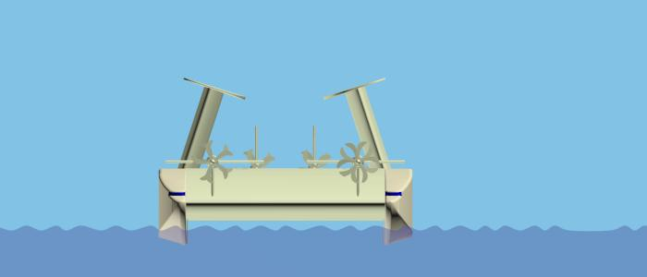
TAKE OFF  CHECKLIST  - FRONT FOILS BASE POS.  - REAR FOILS DOWN  - FLAP/SKIRT DOWN  - WINGS FOLDED DOWN  - TURBOPROPS START UP / IDLING  - WATERJETS IDLING | 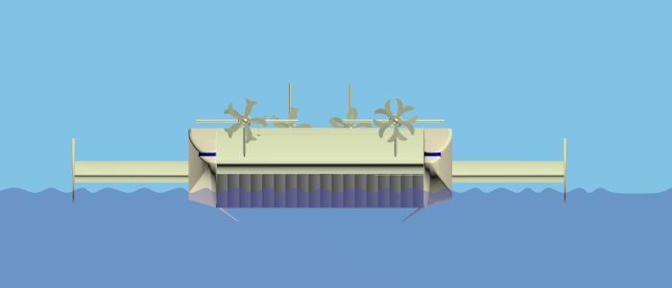
AIRCUSHION PHASE  - WATERJETS FULL ON  - TURBOPROPS FULL ON  - AIRCUSHION INTAKE OPEN  - STABILISATION HULL | 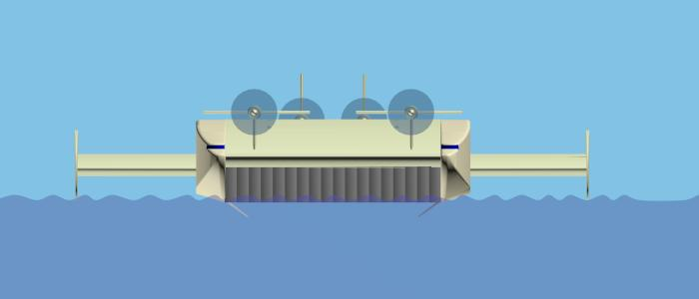
HYDROFOILS PHASE  - TURBOPROPS FULL ON  - AIRCUSHION INTAKE CLOSED  - FLAP/SKIRT UP  - WATERJETS OFF  - FRONT FOILS EXTENDABLE FOR ROTATION  - REAR FOILS DOWN  - STABILISATION HYDROFOILS | 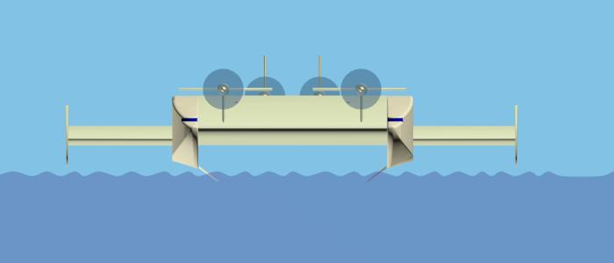
WISE PHASE  (WING IN SURFACE EFFECT)  - STABILISATION AERODYNAMIC  - REARFOILS UP  - FRONTFOILS RETRACT TO BASE POS. FOR  WISE | 